**JUNIOR KING’S SCHOOL, CANTERBURY**

**SCIENCE DEPARTMENT**

**GENERAL REMINDERS FOR ALL OF YOUR SCIENCES**

A few things to remember when you are answering questions:

* ***If you are asked to draw a diagram, use a pencil***
* ***When labelling diagrams, use a pencil and a ruler***
* ***Don’t forget to use arrows, when necessary for example:***

***To show the flow of energy in a food chain***

***To show the direction of a light ray***

* ***You are allowed to use a calculator for all of your science exams…***
* ***..BUT DO NOT FORGET TO SHOW YOUR WORKING AND UNITS AT EACH STAGE!***
* ***When plotting graphs, use a sharp pencil and never use a pen***
* ***On graphs, remember to label your axes, using an appropriate scale, and include a title***
* ***Look carefully at any instructions about joining drawing a line through the points. Use a pencil for this.***
* ***Look at the number of marks available for each question. If more than one mark is available, make sure you add sufficient detail by explaining your answer fully***

**BIOLOGY REVISION NOTES FOR YEAR 7**

These are the topics which may be examined after half term. They should be revised in conjunction with the relevant chapters in the Red textbook and your class notes.

The Science exam will consist of one paper lasting 75 minutes. In it there will be three separate sections for Biology, Physics and Chemistry, each of which should take 25 minutes.

CWL

May 2012

**The Seven Life Processes**

1. Things are alive **if** they carry out the following seven life processes:

grow

reproduce

respire

sense

get rid of waste

feed

move

1. Living things get their energy from food. The energy is released during a chemical reaction called **respiration**:

SUGAR + OXYGEN CARBON DIOXIDE + WATER + ENERGY

1. Oxygen is needed for respiration.
2. Plants can make their own food, using the energy they get from sunlight.
3. Plants trap the sun’s energy using a green pigment called **chlorophyll**.
4. The food-making process in plants is called **photosynthesis**:

bd08059_

chlorophyll

CARBON DIOXIDE + WATER SUGAR + OXYGEN

Sunlight

**Cells**

1. Living things are made up of **cells**.
2. Cells are very small, so are measured in micrometres (m), which are a thousand times smaller than millimetres. 1 mm = 1000 m
3. Animal cells are made up of three main parts:

**nucleus**: controls the cell and contains instructions to make more cells;

**cytoplasm**: where the chemical reactions of the cell take place;

**cell membrane**: contains the cell and controls what passes in and out of the cell.

1. Plant cells are made up of *six* main parts - nucleus, cell membrane and cytoplasm, but they *also have*:

**cell wall**: around the outside to support the cell;

**vacuole**: contains a watery solution called cell sap;

**chloroplasts**: contain the green pigment called chlorophyll which traps the energy from sunlight for photosynthesis.

1. Some cells have special shapes in order to carry out special functions - examples include sperm cells, nerve cells, root hair cells and red blood cells.

**Tissues and organs**

1. Cells are the building blocks of living things like humans.
2. Similar cells are grouped together into **tissues**.
3. Groups of tissues are arranged together into **organs**.
4. Organs work together in **systems**.
5. The **brain** is an organ which oversees the **coordination** throughout the body. It makes sure that the correct responses to messages are sent to the correct parts of the body. It is part of the **nervous system**.

hm00386_

1. The respiratory system includes the lungs and windpipe or **trachea**.
2. The **circulatory system** includes the heart and blood vessels. The heart is responsible for pumping blood to all parts of the body.
3. Your **digestive system** begins at your mouth. Food goes to the **stomach**, then to the **intestines.** Waste that cannot be digested is stored in the rectum until we go to the lavatory.
4. Plants are also made up of organs such as stems, leaves, roots and flowers.

**IDENTIFICATION OF LIVING ORGANISMS**

* The way in which the living world is classified into Kingdoms and further sub-groups.
* The main recognition features of these groups.
* Know the features which define the five groups of Vertebrates (Mammals, Birds, Reptiles, Fish and Amphibia
* Know the major features of Invertebrates, and Arthropods in particular.
* Know the features separating Insects and Arachnids.

# 

**VARIATION AND INHERITANCE**

* All living things have some similarities to their parents. We ***inherit*** some characteristics.
* Other features we have are caused by the environment - they are not inherited.
* Inherited features include hair colour, eye colour, ability to roll tongue, etc.
* Environmental features could include weight - if we eat too much we will put on weight.
* **Chromosomes** are the large molecules in the nucleus of our cells. They are made up of *DNA* which makes up our genes.
* Each human cell (with a few exceptions) contains 23 identical pairs of chromosomes.

**SELECTIVE BREEDING**

Living organisms are given two scientific names (a binomial naming system) – the first is the **genus** and the second is the **species**.

* Organisms are classified on the basis of their shared features.
* We can change the features in animals and plants by ***selective breeding***.
* By mating two animals with desirable features, we are likely to get offspring that inherit those features. If this is done over a number of generations, we can permanently change some features.
* Examples of selective breeding include:

an02492_

* + Cows that produce a lot of milk;
  + Wheat that is disease-resistant;
  + Hens which lay many eggs;

plus many, many other examples.

# Keys

* Keys are used to identify living things.
* Use simple choices when making keys.
* Keys may be laid out like a spider diagram or as a set of word instructions. In each case, choose the most appropriate statement and follow the number instructions.

**Adaptation, habitats and sampling**

1. Animals and plants are **adapted** to living in particular habitats.
2. Adaptations are ways in which animals and plants are suited to their environments.
3. Living things **compete** for resources such as food and water, shelter, light, oxygen, territories and mates.
4. Animals and plants have adaptations that allow them to compete successfully.
5. Animals and plants that compete successfully will be able to breed.
6. To take samples in a field, we use **quadrats** placed **randomly**. Taking several samples gives a more accurate idea of the plants or animals in the field.

**Feeding relationships**

1. Predators are animals that kill other animals for food.
2. The animals that they kill are called **prey**.
3. Predators are adapted to killing their prey - they are often powerful and fast, and have sharp teeth and claws; many are camouflaged.
4. Prey animals are adapted to escaping from predators. They are often fast and camouflaged; many stay together in groups.
5. There is a relationship between the number of predators and prey. The graph shows this relationship:

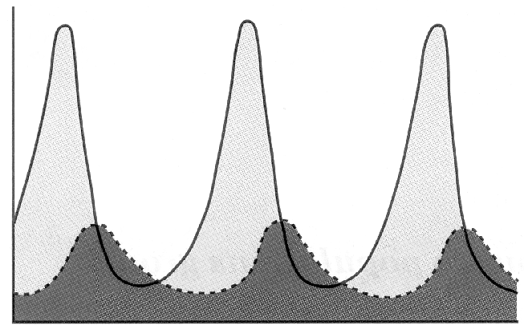

Population size

Time

prey

predator

Populations

1. A **population** is a group of the same animals or plants living in the same habitat.
2. Populations usually grow in the following way:

population

time

1. This kind of population graph shows us that the population grows slowly at first, and then accelerates (the steep part of the line). After a period of time, competition for resources means that the population growth slows down; when the line levels out, the population size remains stable. This must mean that there is an equal number of births and deaths.
2. Population growth can be limited by a number of factors, including light, overcrowding, food and water, disease, climate, predators, oxygen and shelter.

**FOOD CHAINS AND WEBS**

1. Food chains show how energy is passed from one organism to another.
2. A pyramid of numbers, based on a food chain, tells us *how many* organisms are involved at each level of the food chain.
3. There are always **larger** numbers of organisms at the beginning of food chains and therefore on the lowest level of the pyramid.
4. Always start the pyramid with the ***producer*** on the ***bottom*** and the top predator at the top.
5. We can also draw a ***pyramid of biomass*** which shows us the **mass** or **amount** of each group of organisms on each level of the pyramid.
6. An *inverted* pyramid is one which is small at the bottom.

Pyramid of Biomass

Pyramid of Numbers

1 eagle

1 oak tree

20 squirrels

1 eagle

1 oak tree

20 squirrels

1. Pesticides are chemicals that kill **pests**.
2. Pests include insects, weeds, fungi and bacteria.
3. Pesticides can get into the food chain and can affect animals at the top of the chain. An example is DDT causing damage to the eggs of birds of prey.
4. Concentrations of pesticides are measured in **parts per million** (ppm); 10 ppm means 10 molecules out of every million are pesticide molecules, or 10 litres out of every million litres is pesticide.
5. The concentration of pesticides increases as you go up the food chain; the highest concentrations are found in the top predators.
6. ***Decomposers*** are organisms which break down dead plants and animals.
7. The most important decomposers are *bacteria* and *fungi*.
8. Nutrients are recycled because of decomposers. Look at this nutrient cycle:

consumers

feeding

breakdown

breakdown

decomposers

producers

photosynthesis

nutrients in environment

**POLLUTION**

1. Pollution can be caused by a number of things. Types of pollution include:
2. radio-active waste
3. oil spills

in00524_

1. rubbish tips
2. smog
3. detergents
4. acid gases
5. Pollution has a number of effects, depending on the type of pollution. These include:
6. radioactive waste can damage body cells;
7. oil spills kill sea birds;
8. dangerous rubbish tips leak harmful chemicals;
9. smog can cause lung disease;
10. detergents cause the growth of too many water plants;
11. acid gases dissolve in rain to form acid rain which kills trees and water life.
12. Some living organisms are used as *indicators* of pollution. If they are growing in a certain area, then certain types of pollution are not present.
13. **Black spot** is a type of fungus that grows on roses. It cannot grow if sulphur dioxide is present in the air. Therefore, if it *is* growing on a rose, that means that there is no sulphur dioxide in the air. ***Lichens*** are also sensitive to the presence of sulphur dioxide.
14. In some parts of Sweden, lime is being added to lakes to raise the pH closer to neutral.

(The effects of acid rain and atmospheric pollution have changed the pH)

1. Chemical fertilizers contain three important plant nutrients: **nitrogen**, **phosphorus** and **potassium**.
2. Chemical fertilizers are easy to store and to use; farmers know exactly how much to use. These are *advantages*. Disadvantages include the pollution of local waterways.
3. Natural or organic fertilizers break down more slowly, so providing nutrients over a longer period of time; they also provide humus for the soil, which improves aeration and moisture retention.
4. **Algae** are tiny plants which mainly live in rivers, lakes and seas.
5. They are found at the start of many food chains.
6. If there are excess nutrients, algae grow too fast. When they die, the microbes that break them down use up too much oxygen; this starves water animals and plants of the oxygen they need, so all living things in the water eventually die.
7. We can use some animals to give us an indication of how clean the water is.
8. If mayfly larvae or stonefly larvae are present, then the water is very clean; there is no pollution present.
9. If only blood worms and sludge worms are present, then the water is probably quite polluted.
10. Freshwater shrimps and water lice can tolerate *some* pollution; if they are present, then the water may be a little polluted.

**PHOTOSYNTHESIS**

# 

1. Plants use ***photosynthesis*** to make their food.
2. Photosynthesis can be shown by the following word equation:

sunlight

chlorophyll

carbon dioxide + water sugar (glucose) + oxygen

1. In most plants, the glucose made by photosynthesis is turned into **starch** for storage.
2. We can test leaves to see if they contain starch; remember the test for starch: iodine turns blue-black when it comes into contact with starch.

To test leaves for starch:

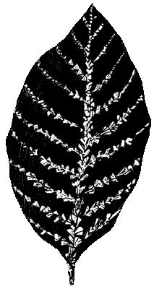

1. Put the leaf into boiling water for about 1 minute;
2. Turn off the Bunsen burner;
3. Put the leaf into a small beaker of ethanol and place the small beaker into the beaker of boiling water. The ethanol will boil and will dissolve the chlorophyll out of the leaf after 5 - 10 minutes;
4. Rinse the leaf in cold water;
5. Put the leaf flat and drop iodine onto it, looking for any colour changes.
6. To find out if light is needed for starch production, we put a plant in darkness for two days to de-starch it. ‘Masks’ with holes in them are put on a couple of leaves and the plant is placed in sunlight. After a day or two, we do the starch test and find that there is only starch present where the holes in the masks were - so light is necessary for

starch production.

1. Plants are green because they contain a green pigment called chlorophyll.
2. Internal structure of a leaf includes:
3. Waxy cuticle - prevents excessive evaporation of water from the leaf;
4. Upper epidermis - is like a ‘skin’;
5. Palisade layer - upright cells which contain many chloroplasts; where most of the photosynthesis takes place;
6. Spongy layer - fewer chloroplasts; has air spaces between cells; xylem and phloem tubes run through this part of the leaf;
7. Air spaces - to allow carbon dioxide to diffuse in and oxygen to diffuse out;
8. Stomata - pores surrounded by guard cells, which open and close to allow carbon dioxide in.

The internal structure of a leaf

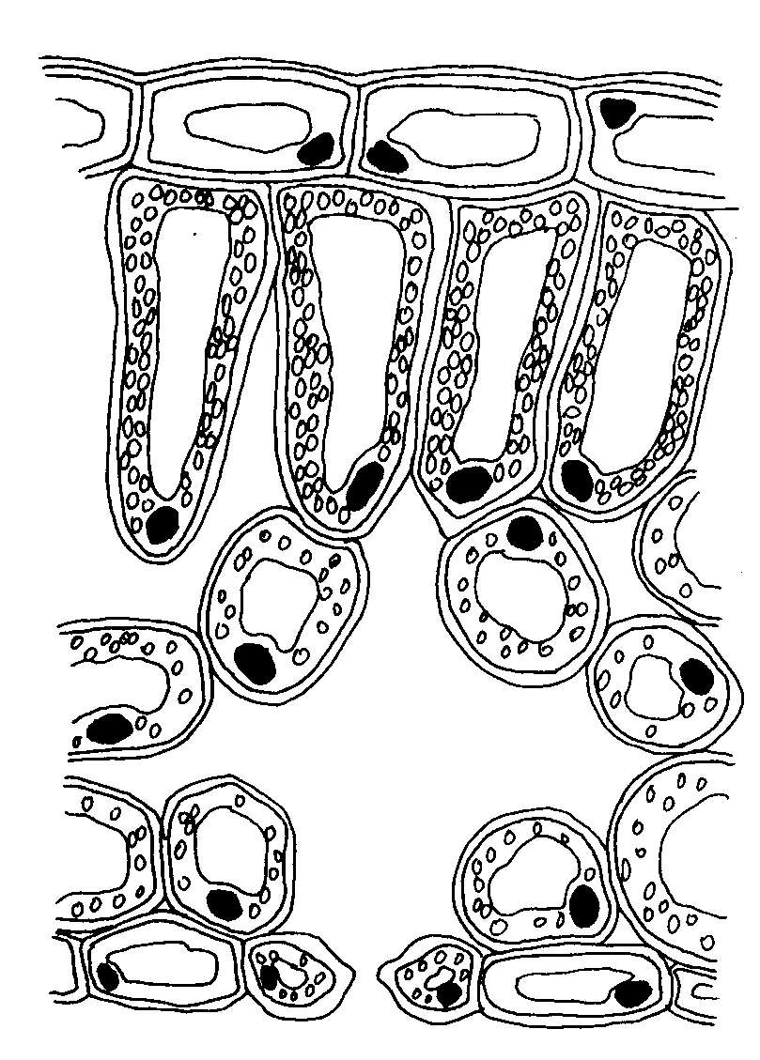

waxy cuticle

upper epidermis

palisade layer

chloroplasts

nucleus

spongy layer

air space

stoma (plural:

stomata)

guard cells

**REPRODUCTION IN PLANTS**

1. Many plants reproduce sexually; that is, they have male and female sex cells (gametes) which must join together to form a zygote.
2. The male gametes are the **pollen grains** and the female gametes are the **ovules**.

petals

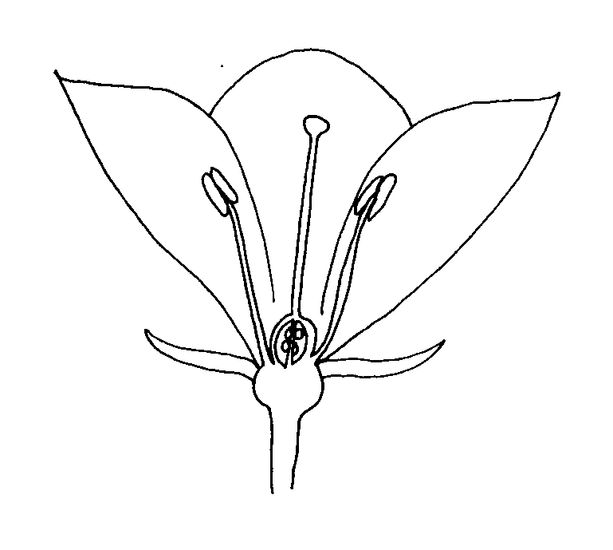

stigma

anther

stamen

carpel

style

filament

style

sepal

ovules

1. Flowers are the **reproductive** parts of a plant; each part of a flower has a function:
2. Petals - brightly coloured, large and scented in order to attract animals, particularly insects;
3. Sepals - small, leaf-like structures which protect the bud;
4. Carpels - the female parts of a flower, made up of:

(a) stigma: sticky, so that pollen sticks to it;

(b) style: holds up the stigma;

(c) ovary: contains the ovules, the female gametes.

1. Stamens - the male parts of a flower, made up of:

(a) anther: holds the pollen grains (male gametes);

(b) filament: holds anthers up.

1. Many flowers also have *nectaries*, which produce **nectar**; insects use nectar as food.
2. ***Pollination*** is the transfer of pollen from the anther of one flower to the stigma of another. It may be accomplished by animals or by the wind.
3. Wind-pollinated flowers do not need to attract insects, so they do not have petals. They do not produce nectar.
4. Once a pollen grain lands on a stigma, a tube (the pollen tube) grows from the pollen grain down the style and into the ovary. There it enters the ovule. The pollen nucleus moves down the tube and joins with the ovule nucleus.
5. ***Fertilisation*** occurs when the *pollen* *nucleus* and the *ovule nucleus* join together. The ovule is now called a zygote. It develops into the **seed**.
6. A seed consists of a hard seed coat, a food store, and the young plant.
7. Seeds require oxygen, water (both for respiration) and warmth in order to germinate.
8. The ovary develops into the ***fruit***.
9. Seeds need to be scattered (**dispersed**) so that there is not too much competition for resources (see Topic 13, lesson 13C).
10. Seeds are dispersed in three main ways:

(a) By wind. Seeds must be fairly small and light, and either have ‘wings’ or hairs to act as a parachute;

(b) By being flicked out of the pod. Some seed pods open in such as way as to throw the seeds out, sometimes over two or three metres;

(c) By animals. This can happen in **two** ways. Firstly, if fruits are bright and juicy, animals will eat them. The seeds usually pass through the animals digestive system unharmed and will be deposited with their own store of ‘fertiliser’! Secondly, some fruits have hooks on them which stick to an animal’s fur, only to fall off some distance away.